**Name** – Bhargav Shamuvel Gurav **PRN** – 2041009

**Class** – L.Y. B-Tech (Computer) **Batch** – B1

**Course Code** – CO406U **Course Name** - CDL

**Practical no. A (3)**

**Aim:** Write a program to recognize strings under ‘a*’, ‘a*b+’, ‘abb’.

**Theory :**

## Automata – What is it?

The term "Automata" is derived from the Greek word "αὐτόματα" which means "self-acting". An automaton (Automata in plural) is an abstract self-propelled computing device which follows a predetermined sequence of operations automatically.

An automaton with a finite number of states is called a Finite Automaton (FA) or Finite State Machine (FSM).

### **Formal definition of a Finite Automaton**

An automaton can be represented by a 5-tuple (Q, ∑, δ, q0, F), where −

* Q is a finite set of states.
* ∑ is a finite set of symbols, called the alphabet of the automaton.
* δ is the transition function.
* q0 is the initial state from where any input is processed (q0 ∈ Q).
* F is a set of final state/states of Q (F ⊆ Q).

## Related Terminologies

### **Alphabet**

* Definition − An alphabet is any finite set of symbols.
* Example − ∑ = {a, b, c, d} is an alphabet set where ‘a’, ‘b’, ‘c’, and ‘d’ are symbols.

### **String**

* Definition − A string is a finite sequence of symbols taken from ∑.
* Example − ‘cabcad’ is a valid string on the alphabet set ∑ = {a, b, c, d}

### **Length of a String**

* Definition − It is the number of symbols present in a string. (Denoted by |S|).
* Examples −
  + If S = ‘cabcad’, |S|= 6
  + If |S|= 0, it is called an empty string (Denoted by λ or ε)

### **Kleene Star**

* Definition − The Kleene star, ∑*, is a unary operator on a set of symbols or strings, ∑, that gives the infinite set of all possible strings of all possible lengths over ∑ including λ.
* Representation − ∑* = ∑0 ∪ ∑1 ∪ ∑2 ∪……. where ∑p is the set of all possible strings of length p.
* Example − If ∑ = {a, b}, ∑* = {λ, a, b, aa, ab, ba, bb,………..}

### **Kleene Closure / Plus**

* Definition − The set ∑+ is the infinite set of all possible strings of all possible lengths over ∑ excluding λ.
* Representation − ∑+ = ∑1 ∪ ∑2 ∪ ∑3 ∪…….

∑+ = ∑* − { λ }

* Example − If ∑ = { a, b } , ∑+ = { a, b, aa, ab, ba, bb,………..}

### **Language**

* Definition − A language is a subset of ∑* for some alphabet ∑. It can be finite or infinite.
* Example − If the language takes all possible strings of length 2 over ∑ = {a, b}, then L = { ab, aa, ba, bb }

# Deterministic Finite Automaton

Finite Automaton can be classified into two types −

* Deterministic Finite Automaton (DFA)
* Non-deterministic Finite Automaton (NDFA / NFA)

## Deterministic Finite Automaton (DFA)

In DFA, for each input symbol, one can determine the state to which the machine will move. Hence, it is called Deterministic Automaton. As it has a finite number of states, the machine is called Deterministic Finite Machine or Deterministic Finite Automaton.

## Graphical Representation of a DFA

A DFA is represented by digraphs called state diagram.

* The vertices represent the states.
* The arcs labeled with an input alphabet show the transitions.
* The initial state is denoted by an empty single incoming arc.
* The final state is indicated by double circles.

### Example

Let a deterministic finite automaton be →

* Q = {a, b, c},
* ∑ = {0, 1},
* q0 = {a},
* F = {c}, and

Transition function δ as shown by the following table −

|  |  |  |
| --- | --- | --- |
| Present State | Next State for Input 0 | Next State for Input 1 |
| a | a | b |
| b | c | a |
| c | b | c |

Its graphical representation would be as follows −

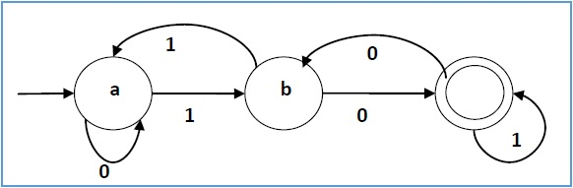

**Program Code:**

#include<stdio.h>

#include<string.h>

#include<stdlib.h>

void main()

{

char s[20],c;

int state=0,i=0;

printf("\n Enter a string :- ");

gets(s);

while(s[i]!='\0')

{

switch(state)

{

case 0: c=s[i++];

if(c=='a')

state=1;

else if(c=='b')

state=2;

else

state=6;

break;

case 1: c=s[i++];

if(c=='a')

state=3;

else if(c=='b')

state=4;

else

state=6;

break;

case 2: c=s[i++];

if(c=='a')

state=6;

else if(c=='b')

state=2;

else

state=6;

break;

case 3: c=s[i++];

if(c=='a')

state=3;

else if(c=='b')

state=2;

else

state=6;

break;

case 4: c=s[i++];

if(c=='a')

state=6;

else if(c=='b')

state=5;

else

state=6;

break;

case 5: c=s[i++];

if(c=='a')

state=6;

else if(c=='b')

state=2;

else

state=6;

break;

case 6: printf("\n %s is not Recognised By the Automata.",s);

exit(0);

}

}

if((state==1)||(state==3))

printf("\n %s is Accepted under rule 'a*'.",s);

else if((state==2)||(state==4))

printf("\n %s is Accepted under rule 'a*b+'.",s);

else if(state==5)

printf("\n %s is Accepted under rule 'abb'.",s);

}

**Output:**

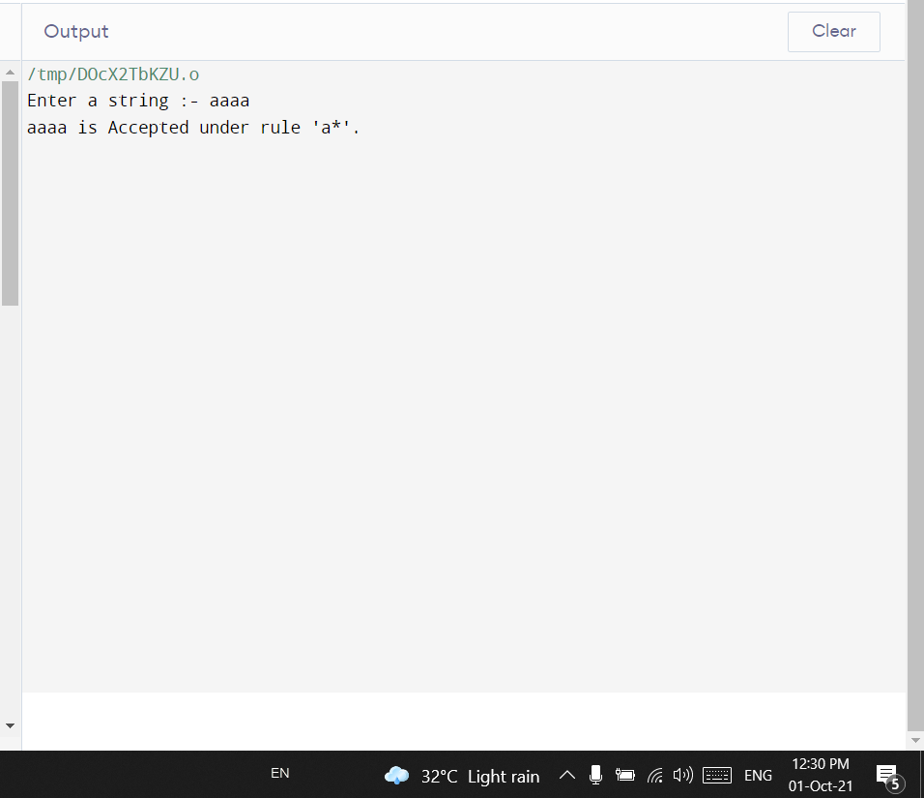

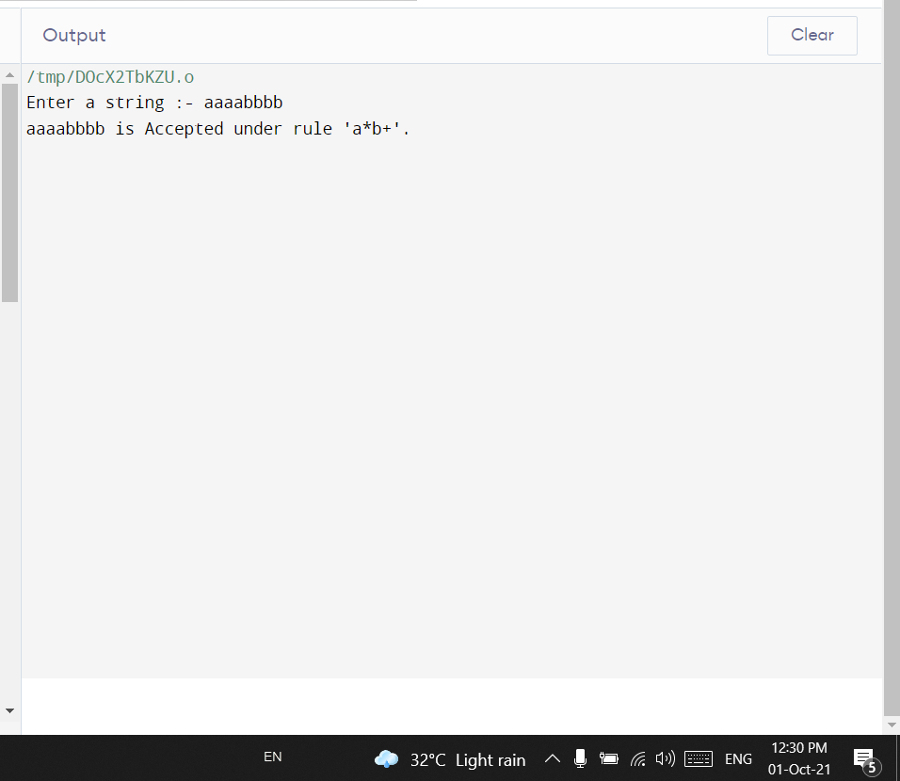

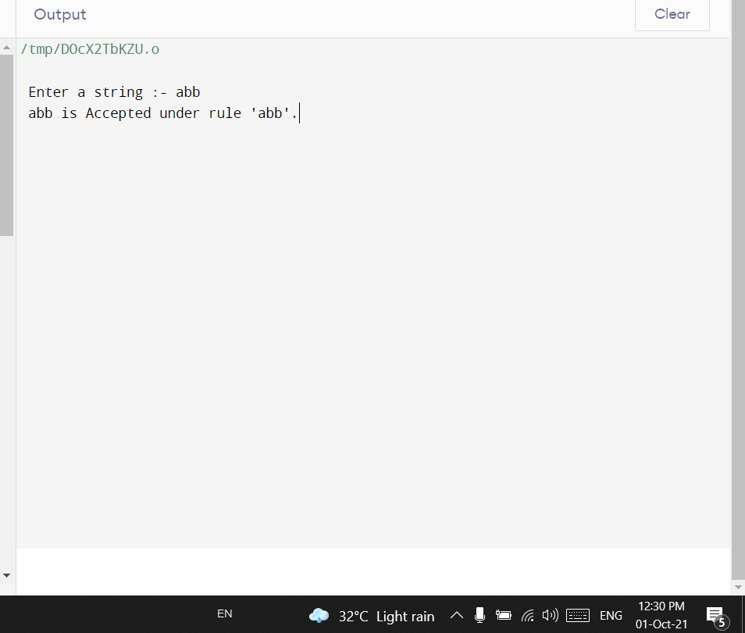

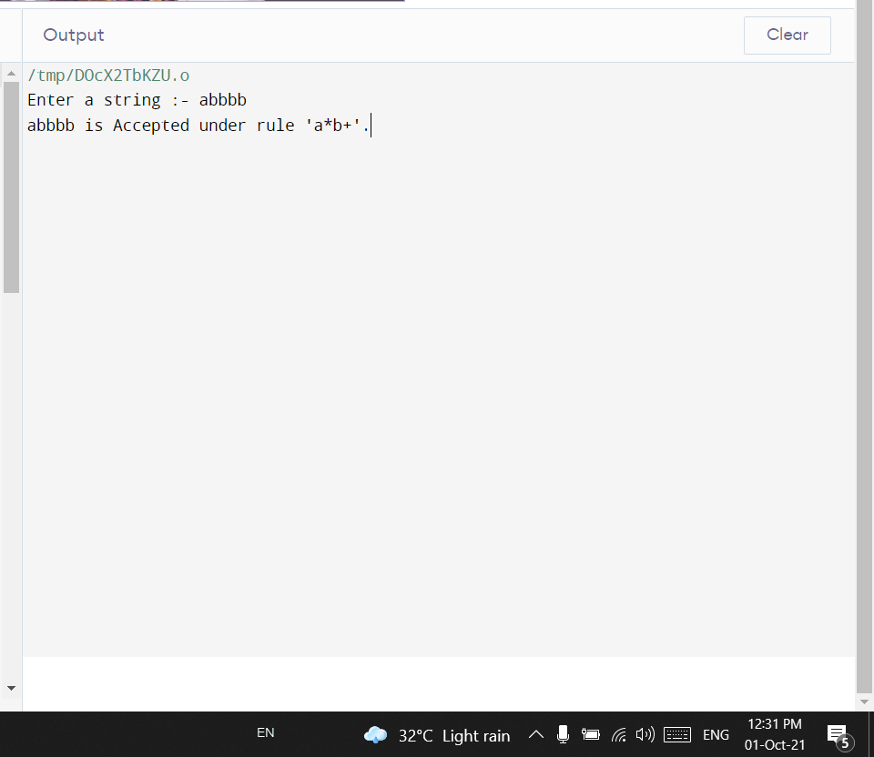

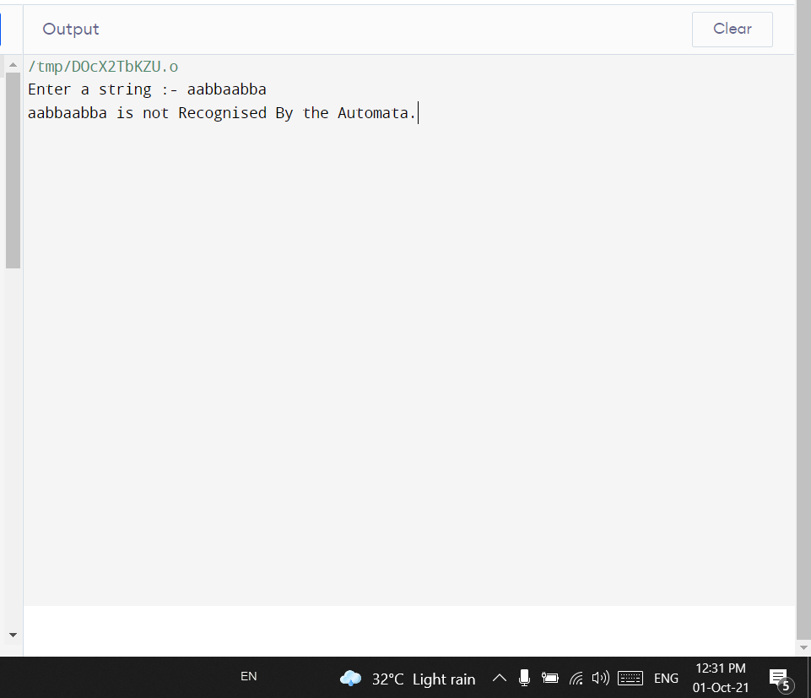

**Conclusion :** In this practical we learnt how DFA recognizes patterns for identifiers, keywords.